
Summative Assessment Memo

Module 4 – Data, Databases and Data Visualisation
Occupational Certificate: Artificial Intelligence Software Developer

Module # | 251201-002-00-KM-04
NQF Level | 4
Notional hours | 80
Credit(s) | 8
Curriculum Code | 251201002
Qualification Title | Occupational Certificate: Artificial Intelligence Software Developer

CONTACT INFORMATION:
Name
Contact Address
Telephone (H)
Telephone (W)
Cellular

PURPOSE OF THE KNOWLEDGE MODULE
The main focus of the learning in this knowledge module is to build an understanding of data and databases and giving meaning to data through data processing, analysis and visualisation

PROVIDER ACCREDITATION REQUIREMENTS FOR THE MODULE:

Physical Requirements:
- The provider must have lesson plans and structured learning material or provide learners with access to structured learning material that addresses all the topics in all the knowledge modules as well as the applied knowledge in the practical skills.
- QCTO/ MICT SETA requirements
Human Resource Requirements:
- Lecturer/learner ratio of 1:20 (Maximum)
- Qualification of lecturer (SME):
- NQF 6 in industry recognised qualifications with 1 year’s experience in the IT industry
- AI vendor certification (where applicable)
- Assessors and moderators: accredited by the MICT SETA
Legal Requirements:
- Legal (product) licences to use the software for learning and training (where applicable)
- OHS compliance certificate
- Ethical clearance (where necessary)
Exemptions
- No exemptions, but the module can be achieved in full through a normal RPL process

TOPIC ELEMENTS TO BE COVERED INCLUDE:

- KM-04-KT01 : Introduction to data
- KM-04-KT02 : Data in spreadsheets
- KM-04-KT03 : Data analytics
- KM-04-KT04 : Introduction to databases
- KM-04-KT05 : Data mining
- KM-04-KT06 : Structured query language (SQL)
- KM-04-KT07 : Visualising data with AI tools
- KM-04-KT08 : Data security

SECTION 1: KM-04-KT01 : Introduction to data

What is a valuable data?
Your most valuable data is first about money and then the many things directly related to money. The value chain for data can be generalized into the degrees of separation between money and the data. The closer to the money that the data is, the higher its potential value.

What is data analysis in artificial intelligence?
AI analytics refers to a subset of business intelligence that uses machine learning techniques to discover insights, find new patterns and discover relationships in the data. In practice, AI analytics is the process of automating much of the work that a data analyst would normally perform.

What is valid and reliable data?
Reliability and validity are both about how well a method measures something: Reliability refers to the consistency of a measure (whether the results can be reproduced under the same conditions). Validity refers to the accuracy of a measure (whether the results really do represent what they are supposed to measure).

What are the errors of omission?
Errors of omission are also sometimes called "false negatives." They refer to instances in which someone or something is erroneously excluded from consideration when they or it should have been included. In survey research, this error typically occurs when the eligibility of a unit is determined.

What are the main errors while collecting data?
The main sources of error in the collection of data are as follows :
- Due to direct personal interview.
- Due to indirect oral interviews.
- Information from correspondents may be misleading.
- Mailed questionnaire may not be properly answered.
- Schedules sent through enumerators, may give wrong information.

What is not valid for data acquisition?
Answer Expert Verified
Announcements are not valid for Data Acquisition. Data acquisition can be described as the collection of data from authentic resources. As a result of data acquisition, there are lesser chances of failure for a certain task.

What are the three types of data acquisition methods?
Mobile forensics data acquisition takes three forms: manual, logical and physical. In this lesson, we'll identify each of these and describe what each method entails for investigators working with mobile devices.

What does an interaction mean in statistics?
In statistics, an interaction is a special property of three or more variables, where two or more variables interact to affect a third variable in a non-additive manner. In other words, the two variables interact to have an effect that is more than the sum of their parts.

What are the 4 data types in MS Access?

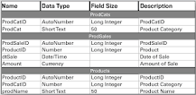

Access: Data Types
- TEXT. Short Text (formerly Text) is a simple data type. ...
- NUMBER. For Number, the critical distinction is made in the Field Size property: Byte, Integer, Long Integer, Single, Double, Replication ID, and Decimal. ...
- DATE/TIME. Date/Time is stored as a number. ...
- CURRENCY. ...
- YES/NO. ...
- OLE OBJECT. ...
- HYPERLINK. ...
- ATTACHMENT.

What is meant by prescriptive analysis?
Prescriptive analytics is the process of using data to determine an optimal course of action. By considering all relevant factors, this type of analysis yields recommendations for next steps. Because of this, prescriptive analytics is a valuable tool for data-driven decision-making.02

When is a calculated field needed?
Raw data can either be structured or unstructured. Structured data used to be in normalized form. Visualizing such data through a dashboard for dynamic analysis requires more granularity. So, not all data fields can be utilized as is to represent KPIs in widgets. This is primarily where a calculated field is needed. There are some situations listed below in which the need for a calculated field arises commonly:
- KPI from a combination of multiple columns in a data source, computing formulas, etc.
- Flag to represent dimension values.
- Customized display text.
How can you use a calculated field?
You can easily create, delete, and update a calculated expression in a Bold BI dashboard and configure the calculated field in a widget like other, normal numeric columns as a quantitative measure.

What is a Excel data model?

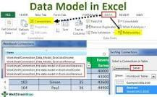

Data model in excel is a type of data table where we two or more than two tables are in relationship with each other through a common or more data series, in data model tables and data from various other sheets or sources come together to form a unique table which can have access to the data from all the tables.

What is the data structure of a spreadsheet?

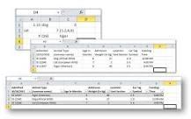

In Excel, the structure is a grid with columns and rows, without many checks on what goes into the cells. An empty spreadsheet is just a bunch of cells in a grid. We can put just about anything into any cell and Excel won't complain about it.

A Data Model allows you to integrate data from multiple tables, effectively building a relational data source inside an Excel workbook. Within Excel, Data Models are used transparently, providing tabular data used in PivotTables and PivotCharts. A Data Model is visualized as a collection of tables in a Field List, and most of the time, you’ll never even know it's there.
Prerequisites
Getting started

What is the reason to import data from table?
Why to import data. table. One of the biggest features of data. table is its concise syntax which makes exploratory analysis faster and easier to write and perceive; this convenience can drive packages authors to use data.

Importing Data from Databases
This topic provides instructions for connecting to a structured data source, such as a Microsoft, Oracle, Hadoop, Teradata, PostgreSQL, or Google database, and importing a predefined schema or writing a schema query that dynamically defines the data to onboard.

Connecting to a Database
- In the Anzo console, expand the Onboard menu and click Structured Data. Anzo displays the Data Sources screen, which lists any existing data sources. For example:
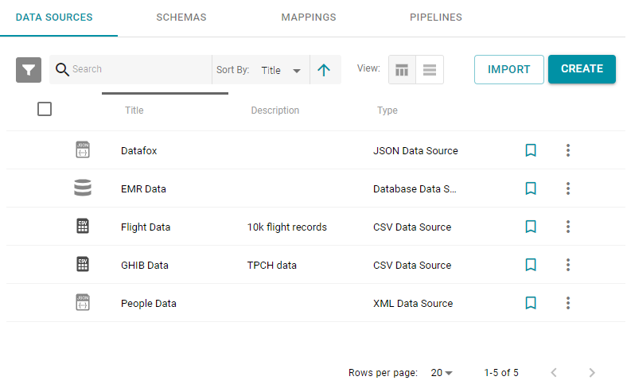
- Click the Create button and select Database Data Source. Anzo opens the Create Database Data Source screen.

SECTION 3: KM-04-KT03:Data analytics

What is data warehouse? Give an example.
Data warehouse is an example of an OLAP system or an online database query answering system. OLTP is an online database modifying system, for example, ATM. Learn more about the OLTP vs. OLAP differences.

What is spatial database?
A spatial database is a general-purpose database (usually a relational database) that has been enhanced to include spatial data that represents objects defined in a geometric space, along with tools for querying and analyzing such data.

What is a streaming database?

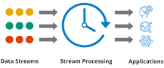

A streaming database is broadly defined as a data store designed to collect, process, and/or enrich an incoming series of data points (i.e., a data stream) in real time, typically immediately after the data is created.

What is data streaming in multimedia?
Data streaming is the process of transmitting a continuous flow of data (also known as streams) typically fed into stream processing software to derive valuable insights.

The basic difference between web mining and text mining arises from the difference between two natures of the data. Text mining imposes a structure to the specified data to be mined for valuable information. Web mining deals with the unstructured forms of data, which includes Word documents, PDF files, and XML files.

What are data operators?
The Operator data type is any expression that is parsed and returns a value, such as tod() , gui() , rtecall() , = (comparison). An operator is a special symbol or function commonly used in expressions.

What is the formula for conditional probability?
Formula for Conditional Probability
P(A|B) – the conditional probability; the probability of event A occurring given that event B has already occurred. P(A ∩ B) – the joint probability of events A and B; the probability that both events A and B occur. P(B) – the probability of event B.

What is inference method?
The classical inference method, also known as probability theory, computes probabilities from multiple hypotheses in order to determine their acceptability. This method is useful to assess two hypotheses at a time.

What is predicting and inferencing?
Predicting Definition: Good readers think about what is going to happen and make predictions based on what they know and what they've read. Inferring Definition: Good readers use what they know (schema) and what they read in the text to make a conclusion (reading between lines).

SECTION 4: KM-04-KT04:Introduction to databases

What are three main components of database?

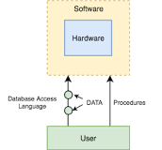

The database management system can be divided into five major components, they are:
- Hardware.
- Software.
- Data.
- Procedures.
- Database Access Language.

What are the five functions of a database?
Database Management System Functions: The Database Management System performs the following functions:
- Data Dictionary Management,
- Data Storage Management,
- Data Transformation and Presentation,
- Security Management,
- Multi-User Access Control,
- Backup and Recovery Management,
- Data Integrity Management,

What is Data Warehousing?
Data Warehouse Defined
A data warehouse is a type of data management system that is designed to enable and support business intelligence (BI) activities, especially analytics. Data warehouses are solely intended to perform queries and analysis and often contain large amounts of historical data.

What is relationship in database design?
Database relationships are associations between tables that are created using join statements to retrieve data. The following table describes the database relationships. Both tables can have only one record on each side of the relationship. Each primary key value relates to none or only one record in the related table.

Is Oracle a relational database?
Oracle Database is an RDBMS. An RDBMS that implements object-oriented features such as user-defined types, inheritance, and polymorphism is called an object-relational database management system (ORDBMS).

What is import and export of data?

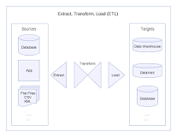

The import and export of data is the automated or semi-automated input and output of data sets between different software applications.

It involves "translating" from the format used in one application into that used by another, where such translation is accomplished automatically via machine processes, such as transcoding, data transformation, and others. True exports of data often contain data in raw formats otherwise unreadable to end-users without the user interface that was designed to render it.

What is query design?

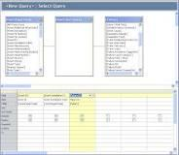

The query design is a visual representation of the families, fields, and criteria that the query is configured to return. When designing a query, you can customize it to return specific records using specific formatting and criteria.

SECTION 5: KM-04-KT05 : Data mining

What Is Data Mining?
Data mining is a process used by companies to turn raw data into useful information. By using software to look for patterns in large batches of data, businesses can learn more about their customers to develop more effective marketing strategies, increase sales and decrease costs. Data mining depends on effective data collection, warehousing, and computer processing.

What are the 6 steps in data mining process?
Data mining is as much analytical process as it is specific algorithms and models. Like the CIA Intelligence Process, the CRISP-DM process model has been broken down into six steps: business understanding, data understanding, data preparation, modeling, evaluation, and deployment.

What is data processing in data mining?
Data processing is collecting raw data and translating it into usable information. The raw data is collected, filtered, sorted, processed, analyzed, stored, and then presented in a readable format.

What are the three 3 challenges of mining large amount of data?
The Big Data introduce unique computational and statistical challenges, including scalability and storage bottleneck, noise accumulation, spurious correlation and measurement errors. These challenges are distinguished and require new computational and statistical paradigm.

What is R tool for data mining?
R analytics is data analytics using R programming language, an open-source language used for statistical computing or graphics. This programming language is often used in statistical analysis and data mining. It can be used for analytics to identify patterns and build practical models.

Oracle Data Miner is an extension to Oracle SQL Developer that enables data scientists and business and data analysts to view data, rapidly build multiple machine learning models, compare and evaluate multiple models, apply them to new data, and accelerate model deployment.

Is SQL a hard programming language?
How Quickly Can You Learn SQL? Generally speaking, SQL is an easy language to learn. If you understand programming and already know some other languages, you can learn SQL in a few weeks. If you're a beginner, completely new to programming, it can take longer.

What is relational database management system RDBMS?
The software used to store, manage, query, and retrieve data stored in a relational database is called a relational database management system (RDBMS). The RDBMS provides an interface between users and applications and the database, as well as administrative functions for managing data storage, access, and performance.

What is the application of SQL?
The major applications of SQL include writing data integration scripts, setting and running analytical queries, retrieving subsets of information within a database for analytics applications and transaction processing, and adding, updating, and deleting rows and columns of data in a database.

What are the advantages and application of SQL?
Complete language for a database: SQL is used to create databases, manage security of a database. While its main use is for updating, retrieving and sharing data with multiple users. Multiple data views: Different users of the database can by SQL be given different views of the structure and content of the database.

What is a ggplot2 in R?

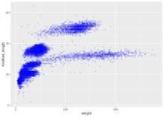

ggplot2 is a plotting package that provides helpful commands to create complex plots from data in a data frame. It provides a more programmatic interface for specifying what variables to plot, how they are displayed, and general visual properties.

Which tools are used for data visualization?
Here are eight important data visualization tools to help data scientists make better-informed decisions.
- Tableau. Tableau is a data visualization tool that can be used to create interactive graphs, charts, and maps. ...
- QlikView. ...
- Microsoft Power BI. ...
- Datawrapper. ...
- Plotly. ...
- Sisense. ...
- Excel. ...
- Zoho analytics.

SECTION 8: KM-04-KT08:Data security
Learning Outcome
- KT0801 Definition
- KT0802 Purpose of protecting data
- KT0803 Process for protecting data
- KT0804 Unauthorised access
- KT0805 Data corruption
- KT0806 Data security solutions

What are the four 4 key issues in data security?
The core elements of data security are confidentiality, integrity, and availability. Also known as the CIA triad, this is a security model and guide for organizations to keep their sensitive data protected from unauthorized access and data exfiltration.

What are the three types of security?

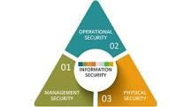

There are three primary areas or classifications of security controls. These include management security, operational security, and physical security controls.

What is the process of data protection?

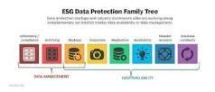

Data protection is the process of safeguarding important information from corruption, compromise or loss. The importance of data protection increases as the amount of data created and stored continues to grow at unprecedented rates.

What are the examples of Unauthorised access?
Know and Prevent the 6 Types of Unauthorized Access
- Tailgating. ...
- Collusion. ...
- Pushing, Crawling Under or Climbing Over. ...
- Passbacks. ...
- Fraudulent Use of Cards. ...
- Door Propping.

What is unauthorized access?
Unauthorized access encompasses any time an individual — an internal or external actor — accesses data, networks, endpoints, applications, or devices without permission. There are several common causes or scenarios of unauthorized data access and unauthorized access to computer networks — from weak passwords that are easily guessed or hacked to sophisticated social engineering schemes like phishing that trick authorized users into exposing credentials, to compromised accounts that have been hacked and taken over by illegitimate actors.

What are data security solutions?
Data security solutions not only focus on preventing malicious or accidental access to data they also focus on protecting the data (and even the hidden metadata) that can contain sensitive information. Modern solutions can utilize cloud-based applications and operate within a hybrid IT environment.

What are Data Security Considerations?
There are a few data security considerations you should have on your radar:
- Where is your sensitive data located? You won’t know how to protect your data if you don’t know where your sensitive data is stored.
- Who has access to your data? When users have unchecked access or infrequent permission reviews, it leaves organizations at risk of data abuse, theft or misuse. Knowing who has access to your company’s data at all times is one of the most vital data security considerations to have.
- Have you implemented continuous monitoring and real-time alerting on your data? Continuous monitoring and real-time alerting are important not just to meet compliance regulations, but can detect unusual file activity, suspicious accounts, and computer behavior before it’s too late.

What are Data Security Technologies?
The following are data security technologies used to prevent breaches, reduce risk and sustain protections.
Data Auditing
The question isn’t if a security breach occurs, but when a security breach will occur. When forensics gets involved in investigating the root cause of a breach, having a data auditing solution in place to capture and report on access control changes to data, who had access to sensitive data, when it was accessed, file path, etc. are vital to the investigation process.
Alternatively, with proper data auditing solutions, IT administrators can gain the visibility necessary to prevent unauthorized changes and potential breaches.

